Date | 11 November 2022
Team ID | PNT2022TMID05082
Project Name | Inventory Management System
Batch number | B11-5A1E
As an admin, I can manage and add users
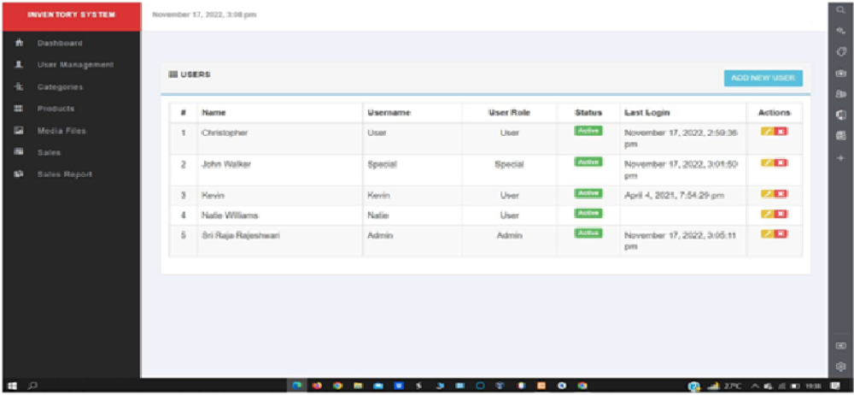

Adding new users by giving correct credentials
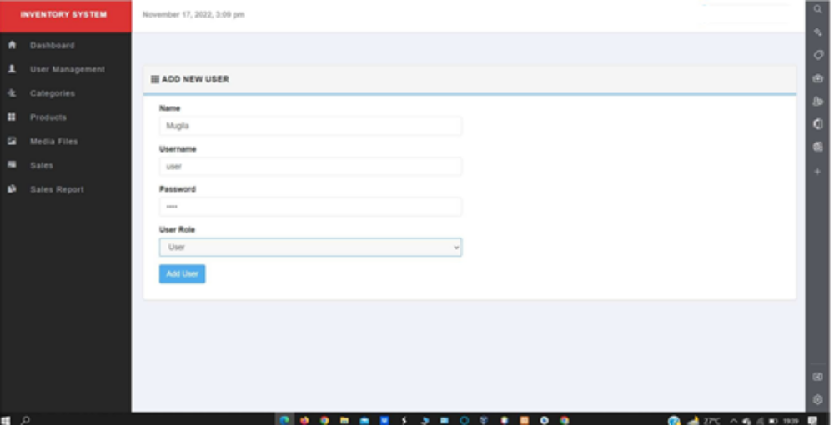

User account has been created successfully

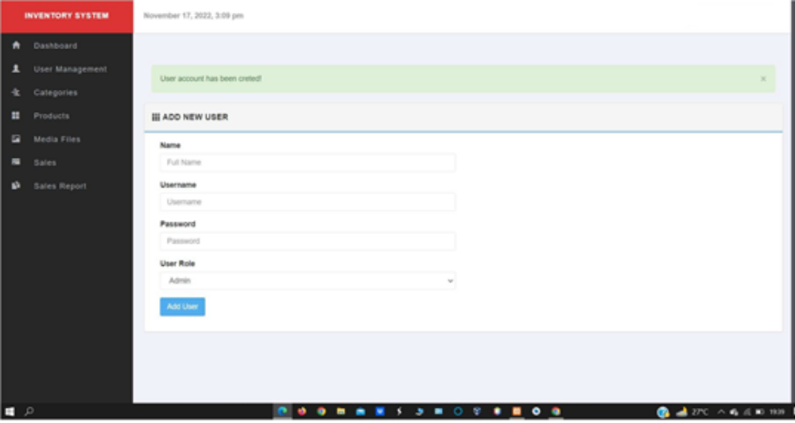

As an admin, I can add new group
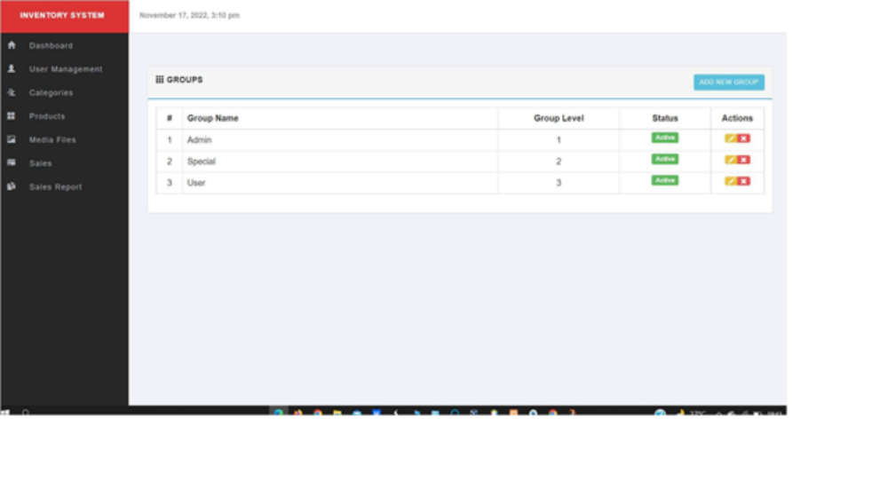

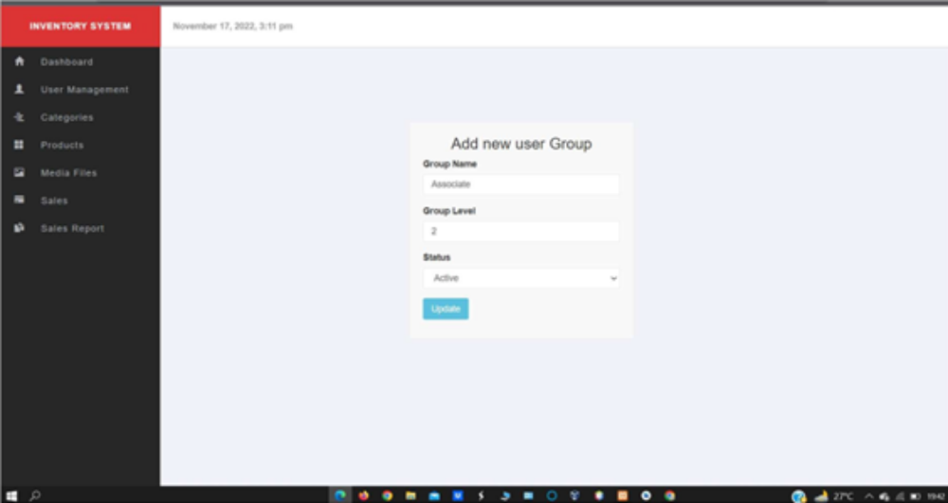

New user group has been created successfully
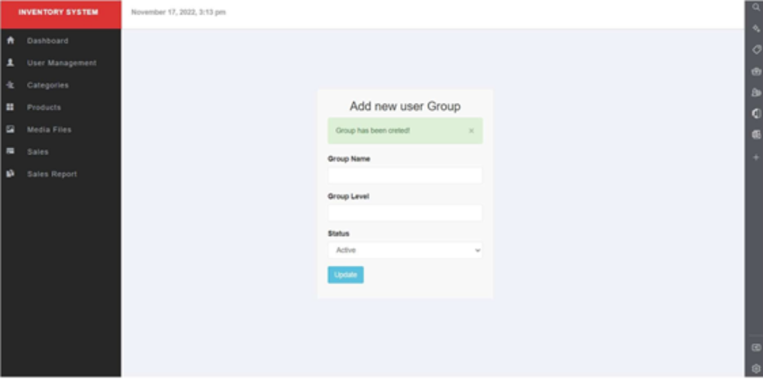

CATEGORIES

As an admin, I can add new category
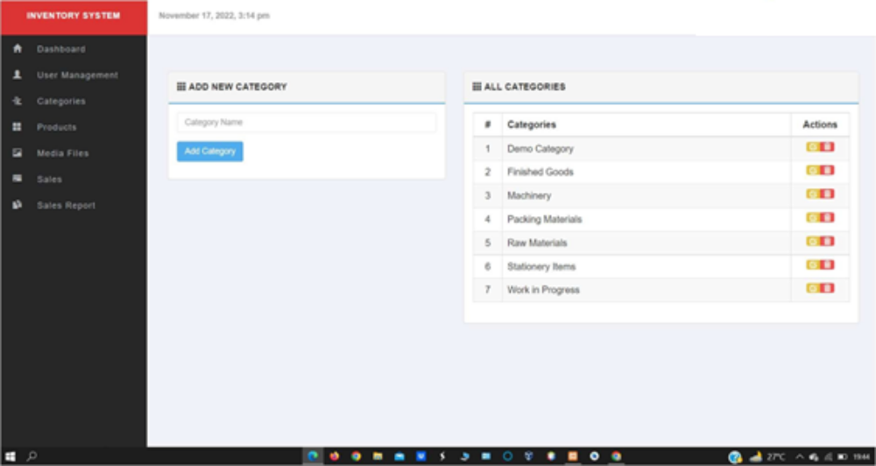

New category has been created successfully
